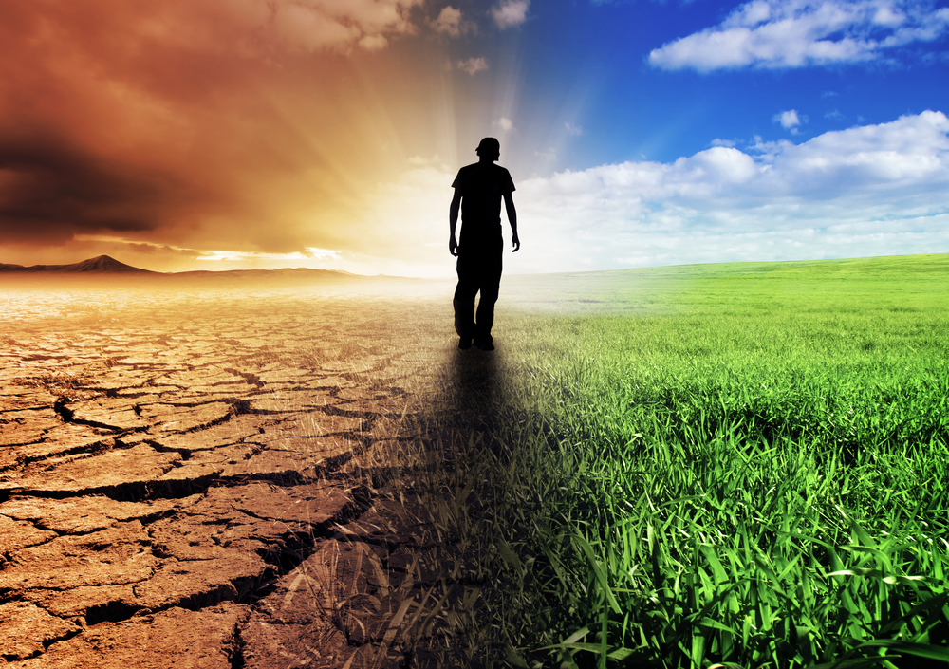
Young Friends of the Earth
Climate Champions Application Form
What?
Young Friends of the Earth Ireland is sending four environmentally conscious young folk ;-) (between the ages of 18 – 30) to Brussels to participate in a week of environmental actions alongside other European environmental activists. This will take place during the Conference of the Parties (COP 21) which is being held in Lima, Peru.
The COP is the name given to the annual meeting of all parties to the United Nations Framework Convention on Climate Change (UNFCCC). All member states who signed up to the UNFCCC come together annually to discuss matters of climate change and each year the conference is held in a different location. During those years that the COP is held outside Europe (Lima 2014), European activists gather in strength around the EU parliament in Brussels.
When?
This year the week of action will be the 6th-13th December and will bring together participants from Young Friends of the Earth networks across Europe as well as other environmentally engaged groups to create actions and awareness about climate justice while world leaders attend the COP.
Who?
This is a great opportunity for those wishing to learn more about how to campaign successfully on issues related to climate justice here in Ireland. This is a fully funded trip with a very important purpose, offering the opportunity to collaborate with like-minded youth and have great fun in the process. Planned activities include interactive workshops on media interviews and non-violent direct action, creating art work, a live link up with International Youth at the UN Climate Talks and a city tour! All in all a wonderful opportunity for those wanting to learn more about these issues and to be part of a movement making a difference and shifting paradigms for future generations.
How?
To help us decide which applicants to send to Brussels, please fill out the application form below expressing your interest and how you intend to create awareness on climate justice issues within your network/community. This may be within your home town, college campus or society, youth group, church or anything else that you are involved in.
The idea is, when the four successful applicants return home from Brussels, they will share their learning, experiences and ideas from the COP with their networks, and the wider public through successful actions and campaigns.
A few examples of previous applicants campaigns and actions include: a campaign linking gender and climate justice and the production of a gender and climate justice tool kit; an environmentally friendly fashion show to demonstrate the impact of buying cheap, unsustainable clothing on our environment and the lives of people in developing countries; an art exhibition; drawing up a plan for a cycle friendly campus and lobbying the student union to initiate the development of this plan... The possibilities are endless ☺
If you want to use your skills, passions and networks to spread awareness on climate justice we want to hear from you!
Please complete all four questions and send your application to youngfoe@foe.ie with the subject title: Climate Champion!
Applications will be accepted until midnight on Sunday 19th of October.
Best of luck!

Section 1.
- Name:
- Age:
- Gender:
- Status: student/employed/unemployed
- Phone (mobile):
- Address:

Section 2.
- Please explain why you would like to become a Young Friends of the Earth Climate Champion. (100 words max.)
- Please give a brief description of your involvement with Young Friends of the Earth or in environmental or youth activism in general (less experience in this area will not inhibit your application, it is your enthusiasm and action that is important!).
- Please describe your understanding of “Climate Justice” (50 words max.)

Section 3
- Please explain how you will use your skills and passions to engage the networks you are part of to generate interest and create awareness around climate justice (400 words max.)

